Description: In Admin interface try creating email templates.

Steps to reproduce: Login Admin> Go to Email Templates> Create a email template.

**Title**

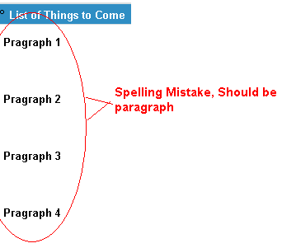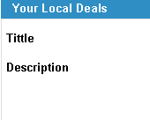

Developer Comments:

Status: Close

Description: In the email generated by client campaign.

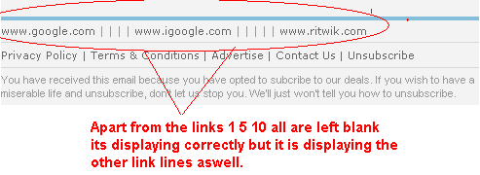

Description: In template 8 for the paragraphs left blank its showing some content by itself.

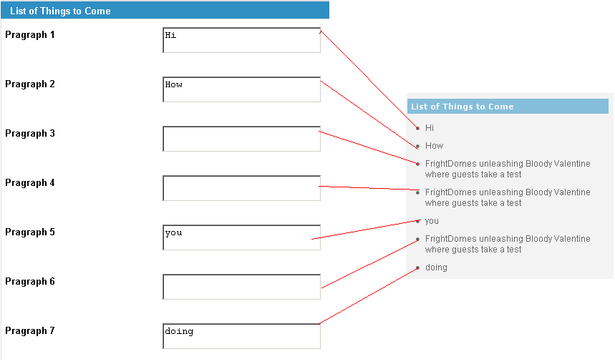

Description: Try creating a campaign in client site

